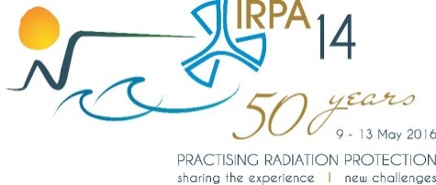
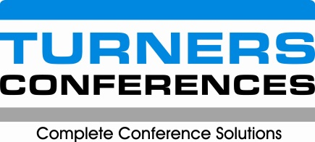

SUPPORT FUNDING TO IRPA14

Following requests received for funding for attendance and participation at IRPA14, the following guidelines and processes should be considered to formulate a firm policy and process.

- FUNDING

  - Funding will be provided to deserving students and delegates subject to funds being available in the Congress account for this specific purpose.
    - Funds may be received from the Montreal Fund, the NRF-DST conference fund or from sponsors, government and other sources.

- SELECTION COMMITTEE

    - A Selection Committee consisting of members of the International Scientific Programme Committee and the Montreal Fund Committee (or as appropriate) will be set up to oversee the funding programme.
  - The Selection Committee will adjudicate in all matters pertaining to qualification for and values of funding.
  - The decisions of the Selection Committee will be final in all matters pertaining to funding.
  - Turners Conferences are to administer the funding processes in conjunction with the Selection Committee.

- CRITERIA

  - Criteria are set for students and others to qualify for access to funding. These include:
    - The applicant must be from a lower income, lower-middle income or upper-income country;
    - The applicant must have submitted an abstract;
    - The abstract must be accepted as an oral or poster;
    - For applications from the Montreal fund, the applicant must be a full time student properly enrolled to the current year in a recognised academic institution and/or a young professional preferably from developing countries and countries that do not have IRPA Associate Societies;
    - For applications from the DST-NRF fund, applicants should be from Africa only;
    - The applicant must complete the full application process and adhere to all terms and conditions.

- APPLICATION PROCESS

4.1 Each applicant will be required to complete the application form in full.
4.2 The application form must be returned to Turners Conferences together with all supporting documents by the closing date indicated on the website.
4.3 Supporting documents include:
4.3.1 Proof of full time enrolment for the current year at a recognised academic institution;
4.3.2 Proof of country of residence.

- AWARDING PROCESS

5.1 Once all applications have been received by the deadline date, a complete report from Turners will be sent to the Selection Committee.
5.2 The Selection Committee will decide on which applicants have been successful based on factors that have been agreed upon such as regional or country proportional representation, quality of abstract or others.
5.3 Preference may be given to Applicants who have raised at least a portion of the funding themselves.
5.3 The Selection Committee will decide on the value of the grant which may include a fixed value amount, registration only, registration and accommodation, registration accommodation and per diem or a combination of the above. Flight costs may also be a factor in the award.
4.5 The Selection Committee will advise Turners of the approved awards.
4.6 Turners will advise the applicants of the decision of the Selection Panel and process the grants accordingly.

- OTHER

6.1 Successful applicants are to register immediately on the official website using the special registration code that Turners assign to them.
6.2 No cash will be sent to the applicant prior to their arrival in Cape Town.
6.3 Travel arrangements, if any, accommodation, and registration are to be done through Turners Conferences.

- END

MONTREAL FUND:
»»» Terms of Reference
The Montreal Fund was created in 1995 by the Canadian Radiation Protection Association with the proceeds of the IRPA8 International Congress held in Montreal, Canada, in 1992, to enhance radiation protection worldwide by supporting attendance of young scientists at IRPA Congresses.
The Fund was transferred to IRPA in 2005 for a total amount of 75,000 Canadian dollars. It is since managed by the IRPA Montreal Fund Committee which has the responsibility to recommend to the Executive Council the amount available each year for distribution and the amounts to be distributed based on the requests received. The chairperson of the committee is appointed by the President from the Executive Council. The IRPA Treasurer is an ex officio voting member of the committee. The Montreal Fund is supported by contributions from Associate Societies and other stakeholders.
Distributions are made to support participation at congresses of students and young professionals preferably from developing countries and countries that do not have IRPA Associate Societies. They are normally made directly to individuals or through the Support Committees for International and Regional Congresses.

Members:
Brad Cassels (Australia)
Kyo-Youn Kim (Korea)
Ken Krieger (USA)
Laura Pring (USA)

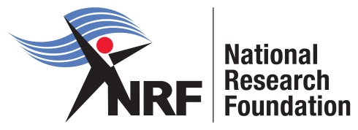

NRF-DST conference fund:
»»» Terms of Reference
It is important to strategically position South Africa as a global player in Research and Innovation. This can be achieved by promoting international collaboration through hosting of strategic global events, support of researcher mobility and participation in scientific events, enriched by national learning opportunities and engagements.
The NRF-DST conference fund is intended to support the hosting of international conferences centred on excellent scientific research that has potential for socio-economic impact. The funding platform makes provision for strategic, large events of an international nature, hosted in South Africa, or on behalf of South Africa abroad. The fund will typically support ‘global conferences’ of more than 1 000 participants.
The overall objectives of this fund are to:
• Promote South Africa as a science destination;
• Increase the competitiveness of the South African National System of Innovation (NSI);
• Showcase South Africa’s scientific endeavours and infrastructure, and to build capacity within the NSI;
• Enhance networking within the science system;
• Foster international collaboration in order to improve the quality of research outputs by researchers.
The NRF-DST conference fund has made available limited funds for sponsoring of participants from Africa only to IRPA14. The IRPA14 Congress Organizing committee has resolved to sponsor the registration fees of a limited number of successful applicants. Please note, sponsorship is not guaranteed unless an applicant receives written confirmation by the indicated date.
WHO MAY APPLY
All applicants who meet the Criteria stated above.

